**Project 1 :** Create a simple calculator ( add, substract, divide and multiply )

**Scenario** :

1 - User enters 2 numeric values in the input fields

2 - Chooses the operation (+, -, / or *)

3 - Get the result in the result field

**Condition :**

1. The 2 fields must be numeric inputs
2. You **can not modify** the result field
3. When user divides a number by zero, an alert will appear to the user.
4. The project must look like the exemple (feel free to choose the buttons colors)

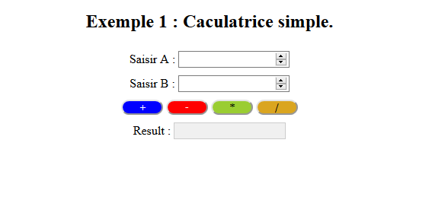

1. The content should be centered.

**Hints :**

HTML : input type number, label, input disabled, label

CSS : background-color, color, border-radius, text-align, margin auto

JS : getElementById, parseInt, onclick